Project Navi[GATOR] : A Mobile Application to Facilitate Navigation and Parking in Urban Areas

**Lingfei Gao Jinnan Lu Jenny Seo**

University of Toronto University of Toronto University of Toronto

[**hob19930414@gmail.com**](mailto:hob19930414@gmail.com)[**owenljn@gmail.com**](mailto:owenljn@gmail.com)[**soyansun@gmail.com**](mailto:soyansun@gmail.com)

**Vince Xie Yifei Yang**

University of Toronto University of Toronto

[**nbxieyu920811@gmail.com**](mailto:nbxieyu920811@gmail.com) **L343558977@gmail.com**

Permission to make digital or hard copies of part or all of this work for personal or classroom use is granted without fee provided that copies are not made or distributed for profit or commercial advantage and that copies bear this notice and the full citation on the first page. Copyrights for components of this work owned by others than ACM must be honored. Abstracting with credit is permitted. To copy otherwise, to republish, to post on servers, or to redistribute to lists, contact the Owner/Author.

**Abstract**

This paper presents a proposed application that facilitates navigation and parking in urban areas. The proposed interface addresses the needs of drivers in urban areas, as determined by a research study conducted by the authors of this paper. Results from our study indicate a real and tangible need to increase the accessibility and breadth of information available to drivers in urban areas. Particularly, findings from our study indicate that the target audience of our study is most concerned with finding affordable and accessible parking, receiving real-time information on road and traffic conditions, and building upon their existing resources. Results from the study and research on existing relevant literature were used to design a product geared towards these users, and a preliminary interactive prototype was created given this information. A peer-review of the prototype was also performed in order to derive the final prototype that is the topic of this paper.

**Author Keywords**

User interface; Driving; Application; Parking; Urban; Navigation

**ACM Classification Keywords**

H.5.2. Information Interfaces and Presentation (e.g. HCI): User Interfaces–input devices and strategies.

**Introduction**

Modern innovation and advances in information technology has allowed for an unprecedented amount of information transmission and reception. Information sharing is more prevalent than ever, and harnessing the ability to share information in order to increase efficiency in assisting with and performing tasks is a goal shared by many. However, navigation systems have largely remained stagnant, and our study has revealed that many remain unsatisfied by the standards of service that are available to users. Notably, automation and accessibility of parking in urban areas has not been standardized or implemented in most regions of the world. In this paper, we propose a solution to navigating around urban areas, increase the accessibility and breadth of information available to drivers in these areas, and design a prototype in which we can best address the issues in finding accessible, affordable parking in a sprawling metropolitan area.

**Background Research**

Accepted extended abstract and papers will be Based on this chosen user group, We researched specific needs they may have that aren’t being addressed by currently available interfaces. In reviewing multiple academic articles, we found significant technological gaps in the areas of driving, finding parking slots and pay for parking fees. We conducted our own study in which we obtained data from several participants whom we’d contacted through school.

The instruments users in this study were a mixture of questionnaires, interviews and daily diaries.

For the questionnaires part, we created the questionnaire form in Google. And asked our participants to finish the questionnaire online.The participants ranged from newbie drivers that just recently obtained G licenses to very experienced drivers that have been driving for over 20 years. We also interviewed four participants who drives in urban area a lot. Moreover, Our group conducted a 5-day session diary for four participants recorded participants’ daily driving activities and driving performance.

According to the data we collected from those three instruments , the results suggest that in-car driving systems present a viable solution to increasing the accessibility and breadth of information to drivers in urban areas, the data suggests that 100% of respondents either do not use in-car systems ir are not satisfied with the current available technology , the majority of respondents are concerned with increasing driving safety, efficiency and they are interested in adding more features to their current information system and most of them would like the information to be delivered visually.

The main problems are noticed are finding an available parking slot and encountering unexpected road conditions which are usually inevitable. Also, drives are concerned that driving information systems can be potentially distracting while driving , although it does not affect experienced drivers too much.

There are several needs that respondents are interested in: 1. Help finding a parking slot, a gas station, ..etc. 2. Real time traffic information updates including traffic jams , car accidents , constructions etc. 3.

AI helper that can understand multiple languages and allow customization of routes,detect fatigue and help prevent car accidents. 4. Display a stereoscopic scene in eyesight.

According to the research results, the driving purposes in urban area are mostly about going to school/work and recreational activities as well as go to remote/inaccessible locations. So the main problems that most urban drivers are facing are consist of finding a parking slot and navigation service.

**Design requirements based on user needs**

Based on the user needs established during the background research, we decided to implement an in-car system that can help urban drivers find nearby available parking slot with navigation service and audio control service. Moreover, our system can also provide payment methods for users to pay their parking fee easily and fast.

**Initial Proposal**

Initially we designed an iPad style on board system with built-in A-GPS(A.K.A Assisted-GPS) as well as WIFI/4G/LTE ports, this device has touch screen and buttons, and it’s positioned to the right of the driver, please refer to the figure 1 & 2 below.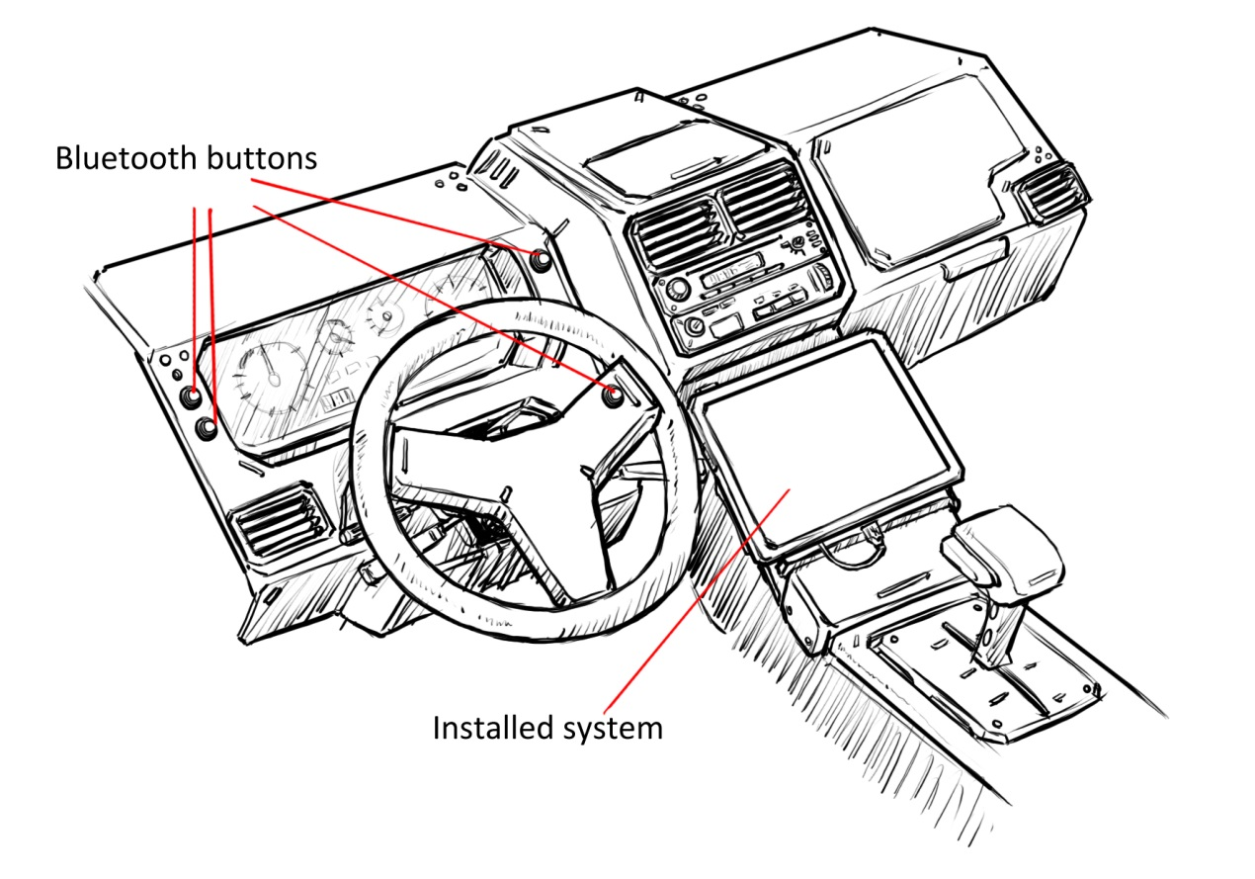

**Figure 1 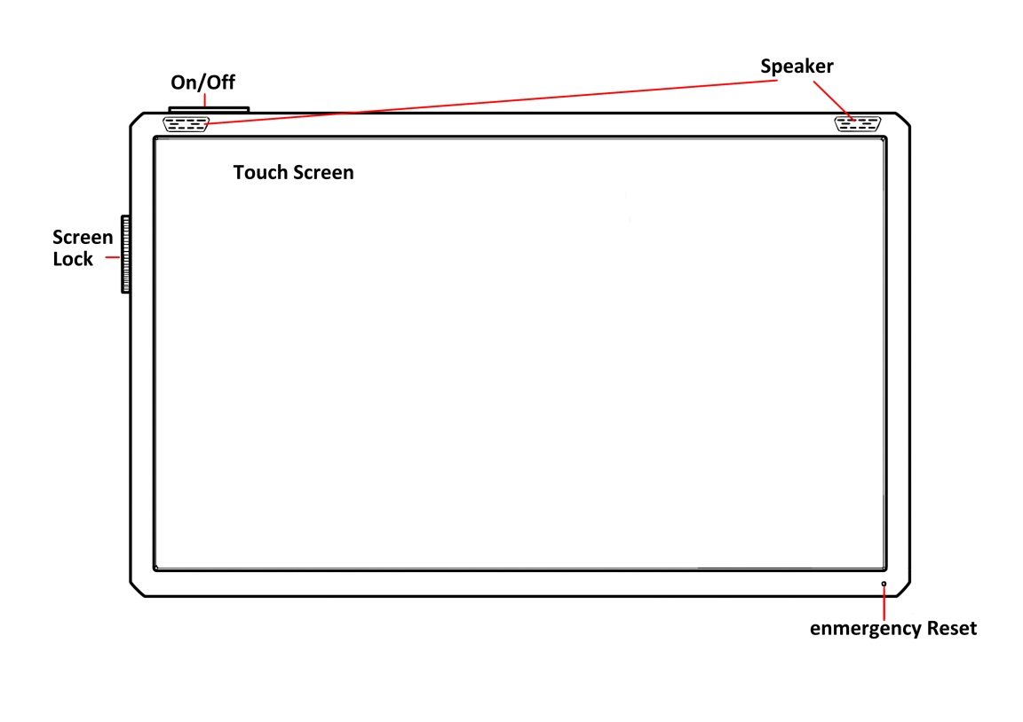Figure 2:**To turn off/on the system, user needs to hold the button at top for a few seconds.

User can turn on the lock switch to lock the control on touch screen or buttons on main device.The device could be hanged in car and need to connect to the car using a USB socket, so that all functions of the device could operate well.

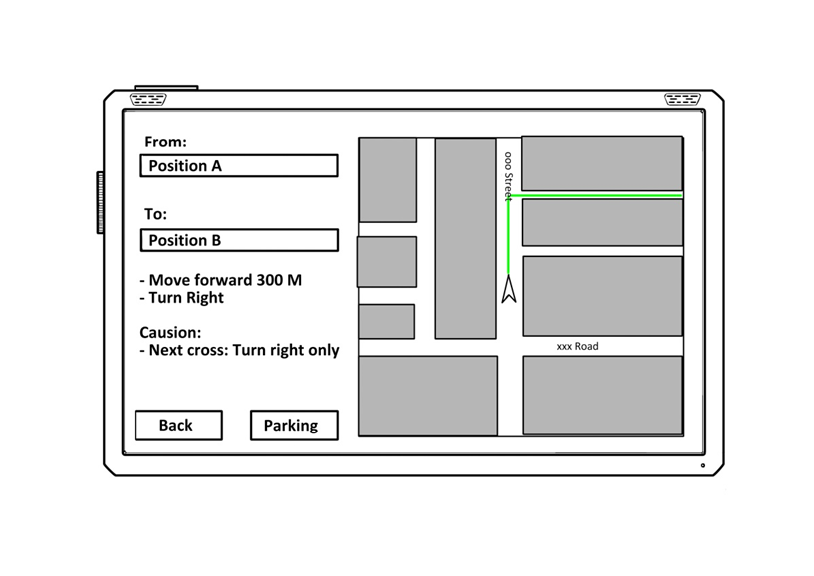

**Figure 3:**The in-car system include the main function of navigation.User can set their destination and the system will find the optimal route based on local map saved in device(updated daily), GPS signal and real-time road condition(will helper user choose faster route).The system will notice user by voice while driving so it won’t distract drivers which prevent them from accidents.

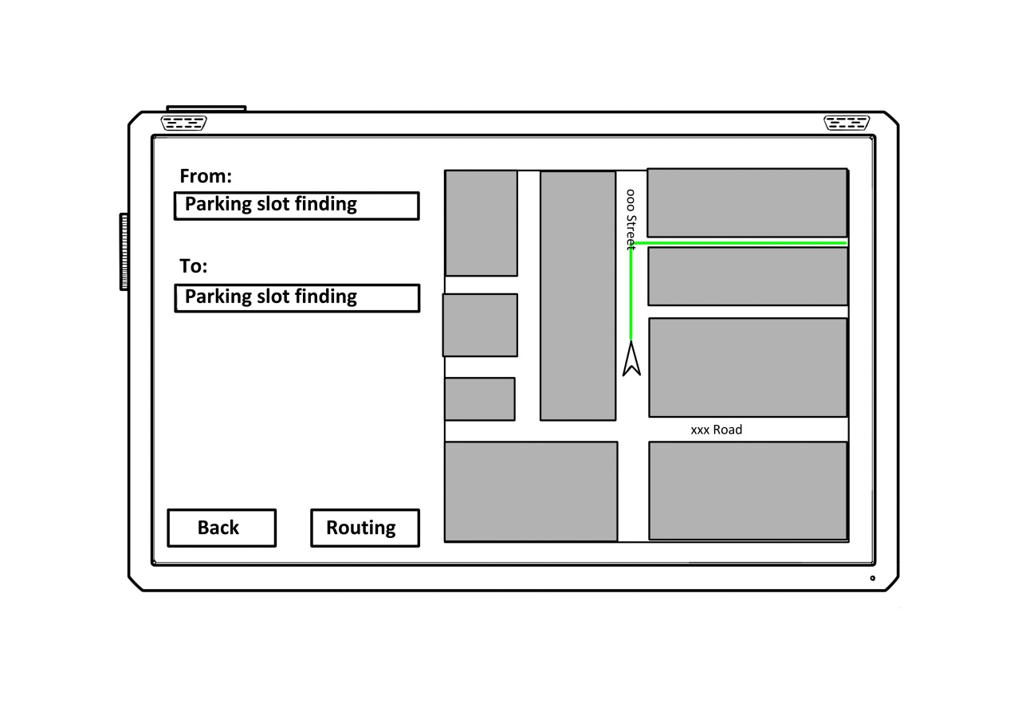

**Figure 4:**In parking mode, the system would scan all the nearby parking space, find the nearest one and route to it. After the optimal parking space located, if possible, the system would pre-take up that parking slot in case of other cars parked into that space before the user’s car arrives.

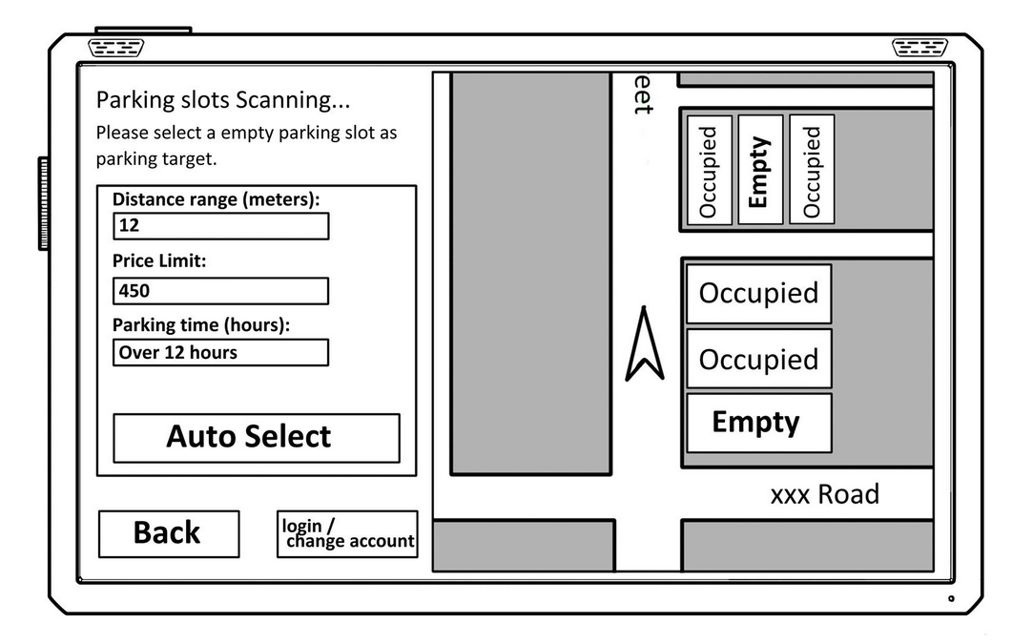

**Figure 5:**By entering the different values indicates your location, price limit and expect parking time, the system will automatically help you find a nearby parking spot(or u can choose it manually) or list several parking spots you can choose from.

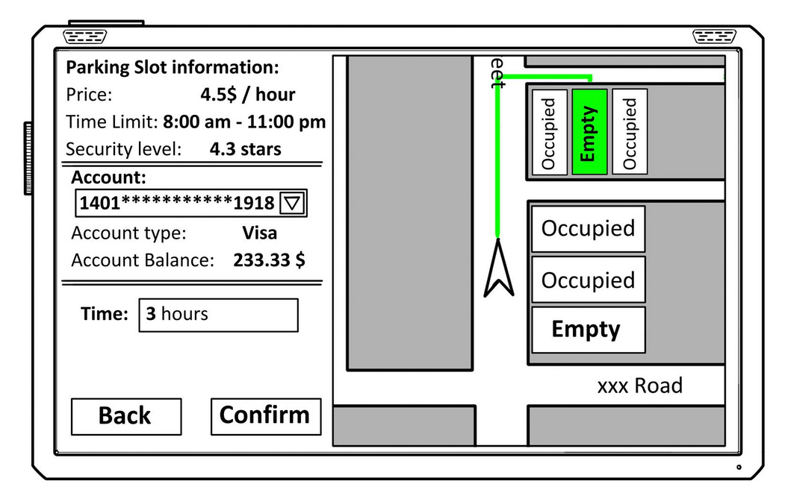

**Figure 6:**The system directly linked to our database and services(also the parking machine) so that people will be able to pay their fees in their car or extend it. However, if people choose not to use the paying system, it is still fine for them to pay manually on the parking machine.The system will detect whether the car is near the parking spot so people will not pre-order the parking spot before they arrived.We accept visa if you don’t have an account, we also provide the account system so people will have register and get some benefit if they stay loyalty.

**Phase 4 Evaluation and Usability Testing**

We have conducted more than 5 interviews and cognitive walkthroughs with members from other groups as well as the TA, we first walked them through the whole process: Start to find a nearest parking slot -> Confirm to navigate to the specified parking slot -> Follow the navigation -> Make the payment online.

Then we let them to go through the questions of our questionnaire, we asked them about their impressions for each of the function by rating them in a scale from 1 to 10:

**Questionnaire on usability feedback**

**1.** Is our product easy to use ?

**2.** what do you think of our product buttons layout ?

**3.** what do you think of finding nearby parking slots feature of our product ? Is it helpful to you?

**4.** What do you think think of our online payment system?

**5.** Do you think our product is efficient ?

**6.** Do you like the way our product interacts with the driver ?

**7.** what do you think of navigation feature of our product ? is it helpful ?

**8.** what do you think of payment methods that are provided by our product ?

**9.** Do you like the way of representing nearby parking slots ?

**10.** Do you like the way of representing navigation guidance?

**11.** Do you like the way of representing payment methods ?

**12.** Do you think our product is distracting while you are driving ?

**13.** Will you buy or use our product after this testing research ?

1. Yes.
2. No.
3. I am not sure.

**14.** What kind of improvement do you think we need to add to the current prototype (Please state below)

They have discovered some critical problems that our prototype has, mainly consists of three parts:

* The device is too big and might cause distractions to driver, a smartphone application can be a better approach which also makes it convenient to carry with the driver.
* The prototype is not interactive enough.
* The layout is kind of confusing that lack of colors and should have better positioning style.

There are also frequently asked questions about :

* How the device connects to internet when there’s bad signal ?
* How the system handles the situation that multiple drivers reserved the same parking slot at the same time ?
* Is the device cost-effective?
* Is the device portable ?

For each frequently asked questions, we have designed a solution for it:

* The device is designed to be functioning within urban areas where mostly are covered by GPS signals, besides, our device also has implemented WIFI and sim-card ports. So if the GPS is malfunctioning, then WIFI/4G/LTE should take over, and navigation service will then be switched to Google Map navigation.
* We use basic FIFO (A.K.A first come first serve) algorithm to handle this situation, so the available parking slots information will be updating in real time to show the occupation status of parking slots to any drivers who may concern.
* This device will be used frequently especially in populated cities where it’s hard to find an available parking slot, so instead of driving around randomly to find a parking slot, this device gives the driver the optimal path, so it’s fairly cost-effective.
* We designed this device in an iPad style which can be simply mounted and unmounted, however, since it has fixed length and width, it might not be fit for all cars.

**Re-designed device proposal**

This re-designed device has changed from an iPad style to a downloadable application based off the suggestions and feedbacks from phase 4 evaluations, this new device is convenient and cost-effective that no additional hardware is required other than a smartphone.

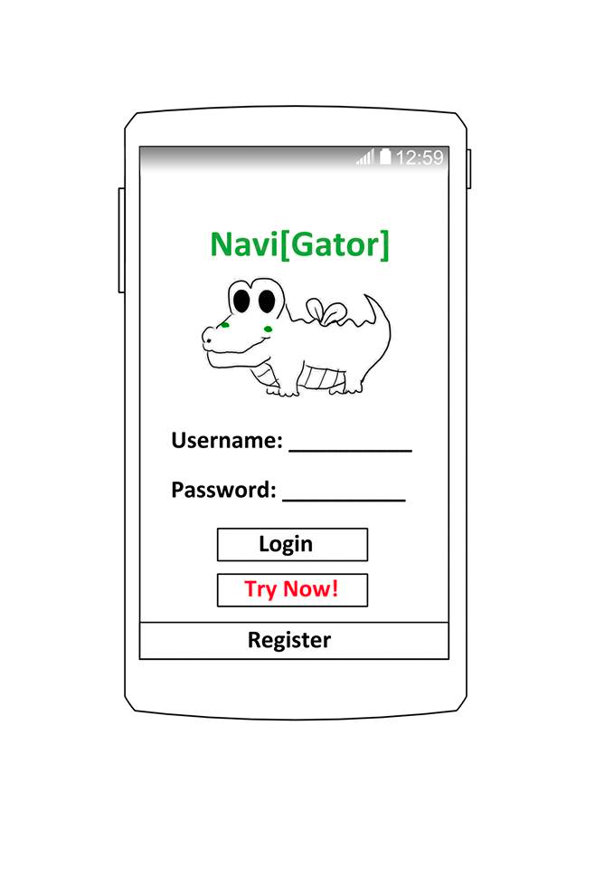

**Figure 1:**Navi[Gator] App can be downloaded from Google Play store for Android systems or Apple store for IOS systems for free.Difference between App version and device version is that App version need internet for both navigation and parking while our device only need internet for parking.(which means you can still use our device to navigate when you have no 3G/4G internet as a normal GPS device).

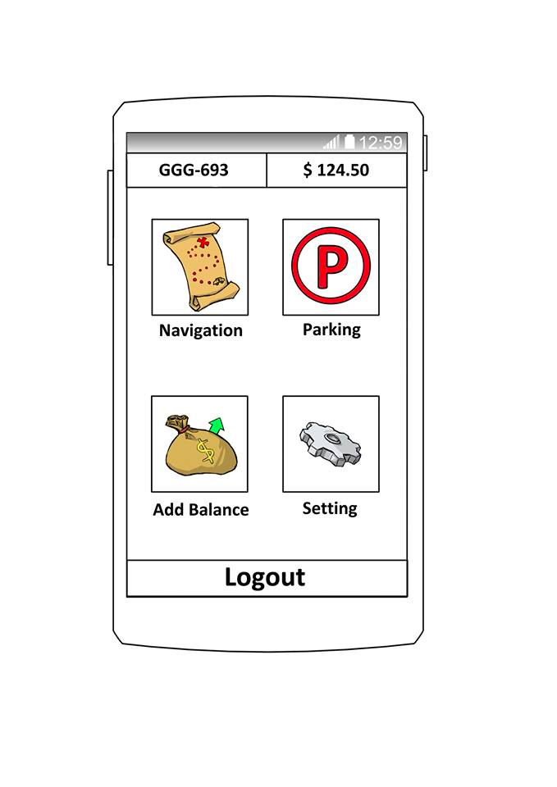

Figure 2:Main menu has 4 button indicating the all 4 functions:

Navigation: Routing

Parking: Search nearby parking slots

Add balance:Add balance to the account

Setting:Change the account-info and system setting

We will add more buttons/function for later updates

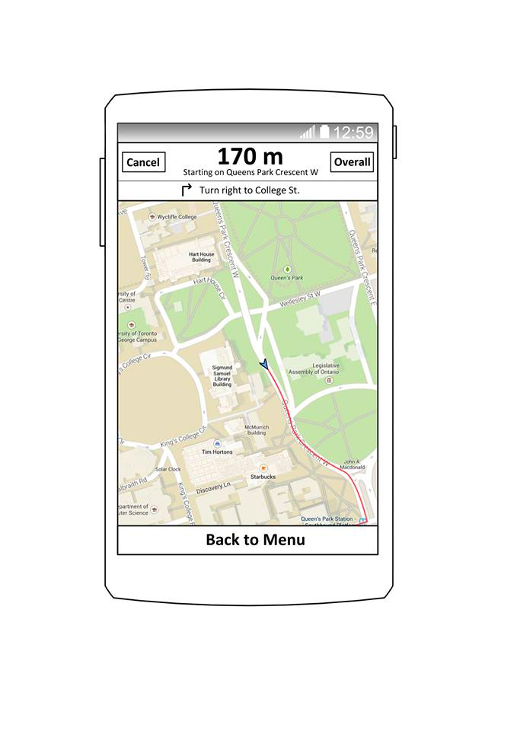

Figure 3:Routing interface is similar to other navigation app. Enter the destination and click the “Go” button to start navigation.

The App will tell you the route by voice and you can cancel it at any time.

By clicking the arrow, you can switch locations of “from” and “to”.

By clicking the overall button, you can see the overall route.

In the Parking interface, the app will automatically detect the current location (or you can manually enter it by clicking the arrow beside distance), and sort them by option you choose(you can also select price, score etc by clicking the arrow button).

You can click the name to start park routing right away or you can click the detail to see more information.

After selecting the parking slots, system will automatically assign you a empty spot,and then the app will direct you to your destination.

Once you reach your destination, the system will detect it and pop the payment window.

The system will hold the spot for users for 5 minutes, so other people who use the App will not assign the same spot to them.

There will be multiple payment methods that can be chosed.

**Future Improvements**

Future steps in the project include further prototype testing by end-users and experts in order to gain feedback on the new design and refine the device further. Once done, we would like to create a physical prototype to allow actual interface testing and by normal urban drivers

**Acknowledgements**

We thank all of our research participants whose insights and stories inspired us to propose this device. We would also like to thank the students of CSC318 who evaluated our prototype and provided us with constructive feedback. We appreciate Eugene Cheung, our course TA for his constructive comments and great facilitation skills. Finally, we would like to thank sincerely Velian Pandeliev, our course instructor, not only for his thought-provoking lectures which are full of wit and humour, but also the support and intellectual stimulation that we received from him.

**References**

[1] Google Corporation, <http://www.google.com>